General Biology Year 11

 Unit 2 - Solving problems

to survive

Task 10: Test – Functioning organisms

(weighting 10%)

**Name: __________________________ Date: _____________**

**Time permitted: 55 minutes**

|  |  |  |  |  |
| --- | --- | --- | --- | --- |
|  | Section | Number of questions | Marks available | Marks achieved |
| A | Multiple choice | 20 | 20 |  |
| B | Short answer | 5 | 28 |  |
| C | Extended answer | 1 | 5 |  |
|  | **Total** | **26** | **53** |  |

**Comments:**

____________________________________________________________________________________________________________________________________________________________________________________________________________________________________________________________________________________________________________________________

Section A Multiple choice (20 marks)

Section A consists of 20 questions, each worth one mark. Each question has only one correct answer. Circle the correct answer. Attempt all questions. Marks will not be deducted for incorrect answers. You are advised to spend no more than 25 minutes on this section.

1. Which list below correctly shows the levels of organisation in an organism in terms of increasing complexity?

1. organism, cells, tissues, organs, systems
2. tissues, cells, systems, organs, organism
3. organs, tissues, systems, cells, organism
4. cells, tissues, organs, systems, organism

2. Why do we need to use animals for research and teaching?

a) animals are good for emotional support

b) what we learn from animals is useful in human and animal medicine

c) the functions of cells and organs are not the same in animals and humans

d) All of the above

3. High surface area to volume ratio allows cells to do what quickly?

a) move materials around inside the cell

b) communicate to other cells

c) move materials in and out of the cell

d) divide

4. Which of the following will NOT increase the surface area to volume ratio of a cell?

a) a folding of the cell membrane

b) the process of cell division

c) an increase in the size of a cell

d) a flattening of the cell

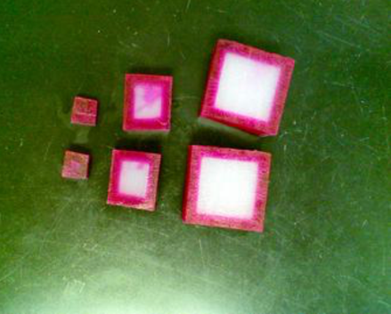5. This image on the right shows how materials move into various sized cells in a given amount of time. Why does one square cell have more pink colouring than the others?

1. the surface area was too large to get through
2. the volume of the other cells was too large for the dye to get through
3. there was not enough surface area for the dye to get through
4. the volume was too low for the dye to stay in the square

6. Different organisms have a range of specialised structures and surfaces for gas exchange. Which of the following animals have a trachea?

a) Earthworms

b) Grasshoppers

c) Cnidarians

d) None of the above

7. Oxygen enters the body of a grasshopper through:

a) gills

b) spinnerets

c) spiracles

d) alveoli

8. Gas exchange through the skin supplements the gas exchange occurring in the lungs of

a) birds

b) amphibians

c) reptiles

d) insects

9. Which of the following is not likely to be present in a herbivore?

a) Rumen or caecum

b) Bacteria in the gut

c) Long large intestine

d) Canine teeth

10. What is a major role of saprophytic fungi in a terrestrial ecosystem?

1. Trap atmospheric carbon dioxide
2. Parasitize plants and animals
3. Break down carbon compounds
4. Serve as pathogens for plants

11. What is the function of plant roots? To

1. collect sunlight
2. absorb nutrients from the soil
3. produce flowers for reproduction
4. eliminate wastes from the leaves

12. In vascular plants, the____________ transports water and minerals from the roots to the rest of the plant.

1. xylem
2. phloem
3. cotyledons
4. sepals

13. What does phloem carry in the stem?

a) sugar

b) oxygen and carbon dioxide

c) water

d) all of the above

14. The loss of water vapour from leaves and stems of plants by means of evaporation through the stomata is known as:

1. perspiration
2. evaporation
3. transpiration
4. condensation

15. Which of the following is correct about blood capillaries?

1. Form connection between veins and arteries
2. Exchange materials between blood and tissue cells
3. Are very tiny blood vessels
4. All of the above

16. For which of these systems are the kidneys in human beings a part?

1. Nutrition
2. Respiration
3. Excretion
4. Transportation

17. What are the main waste products of the kidney?

a) Urea, water and carbon dioxide.

b) Urea and salts.

c) Urea.

d) Urea, salts and water.

18. In what part of the body is the waste filtered from blood?

1. Liver.
2. Bladder.
3. Intestine
4. Nephrons.

19. What are the major excretory organs of vertebrates?

1. Liver and gills
2. Gills and lungs
3. Liver and kidneys
4. Kidneys and lungs.

20. The main nitrogen-containing waste excreted in urine is:

a) ammonia

b) amino acids

c) nucleotides

d) urea

**END OF MULTIPLE CHOICE QUESTIONS**

Section B Short answer (28 marks)

Section B consists of 5 questions. Write your answers in the spaces provided. You are advised to spend 20 minutes on this section.

**SECTION B**: **Short Answer Questions**

1. Complete the table below by defining the following terms: (3 marks)

|  |  |
| --- | --- |
| Terms | Definition |
| Heart |  |
| Saprophyte |  |
| Parasite |  |

2. The dimensions of two different cells are shown below as well as details of their surface area and the formula for calculating volume.

a) Calculate the Surface Area to Volume Ratio for each of the cells. (2 marks)

_____________________________________________________________________________________________________________________________________________________________________________________________________________________

b) Considering the Surface Area to Volume Ratio only, state which cell is more likely to divide and explain your answer. (2 marks)

_____________________________________________________________________________________________________________________________________________________________________________________________________________________

c) **List** the **three** characteristics that make an efficient gas exchange surface. (3 marks)

1.__________________________________________________________________

2.__________________________________________________________________

3.__________________________________________________________________

d) The maximum amounts of oxygen that can be supplied to each gram of

muscle tissue in 1 hour are earthworm 60 mm3, mouse running 20 000 mm3

and butterfly flying 1 00 000 mm3.

**Explain** why the earthworm has such a limited supply of oxygen.

(2 marks)

_____________________________________________________________________________________________________________________________________________________________________________________________________________________

3. The use of rabbits and other animals to test cosmetics is considered unethical while the use of animals to test new drugs and medicines for use in treating human disease is considered ethical.

What is the **difference between these two situations** that results in the difference in ethical view? (2 marks)

_____________________________________________________________________________________________________________________________________________________________________________________________________________________

_____________________________________________________________________________________________________________________________________________________________________________________________________________________

_____________________________________________________________________________________________________________________________________________________________________________________________________________________

4. Large multicellular organisms have transport systems to allow efficient exchange of substances between the cells and the environment.

1. What is the function of the Circulatory System? (1 mark)

______________________________________________________________________________________________________________________________________________

b) Name the three components of the circulatory stem and state the function of each.

(3 marks)

|  |  |
| --- | --- |
| Name | Function |
|  |  |
|  |  |
|  |  |

c) The diagram below is an artist’s illustration for two **different types** of circulatory systems (Type 1 and Type 2).

**STRUCTURE B**

**STRUCTURE A**

Type 1 Type 2

a) **Identify** the types of circulatory systems illustrated above. For each one, provide an example of an organism that has this type of circulatory system. (2 marks)

**Type 1:** ____________________ circulatory system.

Example of an organisms with this type of circulatory system___________________.

**Type 2:** ____________________ circulatory system.

Example of an organisms with this type of circulatory system___________________.

b) For each type of the circulatory system, identify the structure labelled ‘A’ and state its function. (3 marks)

**Type 1:** Structure labelled ‘A’ is ____________________________.

The function of this structure is __________________________________________

_____________________________________________________________________________________________________________________________________________.

**Type 2:** Structure labelled ‘B’ is ____________________________.

The function of this structure is __________________________________________

______________________________________________________________________________________________________________________________________________

5. Examine the skull shown below.

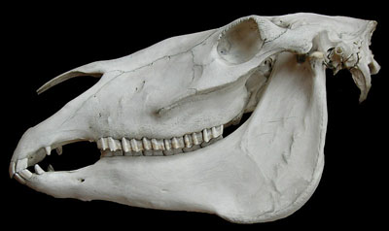

a) State what the diet of the animal is likely to be. ________________________ (1 mark)

b) Explain 2 reasons for your choice. (2 marks)

_______________________________________________________________________

_______________________________________________________________________

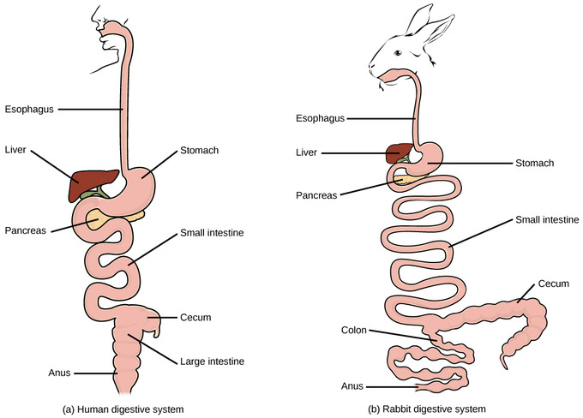

c) Name and explain 2 main differences between these 2 digestive systems. (2 Marks)

Ist difference ______________________________________________________

Reason. __________________________________________________________

2nd Difference ______________________________________________________

Reason. __________________________________________________________

Section C Extended Answer (5 marks)

Section C consists of 1 question. Write your answers in the spaces provided. You are advised to spend 10 minutes on this section.

Plants and animals have a range of specialised structures for obtaining gas exchange. Explain the different methods that a mammal has compared to a green plant.

__________________________________________________________________________________________________________________________________________________________________________________________________________________________________________________________________________________________________________________________________________________________________________________________________________________________________________

__________________________________________________________________________________________________________________________________________________________________________________________________________________________________________________________________________________________________________________________________________________________________________________________________________________________________________

____________________________________________________________________________________________________________________________________________________________________________________________________________________________________________________________________________________________

_______________________________________________________________________

_______________________________________________________________________

_______________________________________________________________________